## A2Group8

### Group Personal Interests and Summary

#### Samuel Jones - S3828578

*[Assignment 1 Website]* [*https://vespidis.github.io/*](https://vespidis.github.io/)

I have always had a personal interest in IT mostly from the perspective of video games, I spent my childhood playing video games like The Legend of Zelda and Banjo Kazooie, and other awesome nintendo games, and I became fascinated with the IT world. However, I never really considered a career in it because I was so focused on becoming an engineer, but I eventually realised that my passion for problem solving could be used and applied in programming and development, and so I taught myself some python, and eventually decided to pursue a career in it because the logic of programming seemed to fit with how I thought and processed the world. I have little to no professional experience in the IT world, but I’m excited to see where this degree takes me.

#### Jacob Smith - S3793994

*[Assignment 1 Website]* [*https://jkobie812.github.io/Jacob-s-Profile/Index.html*](https://jkobie812.github.io/Jacob-s-Profile/Index.html)

Hey my name is Jacob I love playing soccer, sports, skateboarding, building websites as i’ve built a few in the past but I got busy with other stuff and started a carpentry apprenticeship and I am really interested in this field of work and I would like to get some knowledge about this sort of field. I am 23 years of age from the central coast. I always had a passion for computers and such from a young age whether it’s gaming, making videos making music and playing a sports I started my career first as a carpenter finished that apprenticeship in 2017 now it’s time to move onto something else, from a young age About 15 I started a forum site about skating as that interested me, and a few other little niches. I guess you could say I’m trying to broaden my choices I have a little bit of experience in building websites to an extent. I’m not a professional I just have minimal knowledge from when I was younger, doing a lot of things online keen to start the next project once I get more knowledge of the course be able to do so many more things like make a few apps and now I think it’s time to pursue a bachelor of information technology I am currently working in the construction industry. I am really interested in Information Technology Because I feel i have really good ideas and i need these skills to be able to change the future for myself.

#### 

#### Scott Smith - S3825329

*[Assignment 1 Website]* [*https://scoot-uni.github.io/Asses1/index.html*](https://scoot-uni.github.io/Asses1/index.html)

I have been working in IT since 2007. During that time I have worked as a Network Engineer, Desktop Support Engineer and most recently a Project Manager. Prior to entering the IT industry, I was a member of the Australian Army for almost 8 years. I am a father of 3 children, who keep me very busy. When I am not spending time with my children, I love to go Mountain Biking. As I live in Canberra, I am very spoilt for places to go riding. As I have worked in the IT industry for over 12 years, I realise there are so many opportunities. I am excited to see where this degree takes me.

#### Kim Ve Jong - S3833727

*[Assignment 1 Website]* [*https://kvjong.github.io/CPT110/Index.html*](https://kvjong.github.io/CPT110/Index.html)

My interest in IT goes back to the 80’s when my friends had an Amiga 500 and a Commodore 64. My first computer was an 80286 pc, before getting 80386Dx 40 and followed by 80486 DX50 in the 90’s. I started in Dos 3.3 and Windows 3.0 and did all my stuff on the pc by then. Assignments and games were all done on a computer ever since. Later in the late 90’s I worked in the IT field of assemble, diagnose and troubleshoot PC’s, servers, printers and operating system in Windows 98 / Se and Windows NT / 2000. By the time Windows XP rolled around, I started to move into Telecommunications industry in Telstra as sub-contract for 3G SDH network growth. The work requires travel around the country, and in my case majority of the east coast of Australia where the population is more dense. I have always kept up to date with IT in terms of hardware and software and I am also a PC Gamer, and have a large collection of games in steam (though I have only played a fraction of those games).

#### David Mulgrue - S3824946

*[Assignment 1 Website]* [*https://S3824946.github.io/S3824946*](https://s3824946.github.io/S3824946)

I’ve been living and breathing IT since I was a young child and we had our first computer, a Commodore 64. I always wanted to work out how they worked, and I was always the one that caught the blame when something went wrong because I was always tinkering, fiddling, and working things out. When finished yr12 I went into a course doing Computer forensics, which gave me enough knowledge and experience to jump into an IT support role after I dropped out of the course. Since that first job in IT, I’ve worked a lot of positions both in and out of IT, I’ve studied an Advanced Diploma in Video Game Art and Animation, and generally gained a great appreciation for the diversity and hard work that goes into even the seemingly simple games I play. Looking to the future, I plan to focus on software engineering and programming to finally make my own way in the IT industry.

### Team Personality Profile

#### Our Results

|  |  |  |  |  |  |
| --- | --- | --- | --- | --- | --- |
| Test results | Samuel Jones | Jacob Smith | Kim Ve Jong | Scott Smith | David Mulgrue |
| Myers-Briggs | INTP | EFSJ-A | INFJ-A | ESTJ-A | INFP-T |
| Learning Style | Audio/Visual | Audio/Visual | Visual | Visual | Visual/Tactile |
| Unique Tests | [Creativity Test](https://www.mindtools.com/pages/article/creativity-quiz.htm) | N/A | [Psychometrics Test](https://openpsychometrics.org/tests/IPIP-BFFM/results.php?r=2.5,3.9,3.9,4.1,3.8#_V) | [Creativity Test](http://www.testmycreativity.com/share/1E573be6d26c) | Big Five - High Openness |

#### Observations

The biggest overarching factor for our personality test results is that we have a lot in common as a group, combining our strengths but highlighting our weaknesses. Overall, we have a tendency towards both introversion and visual style learning, which means that we may have a hard time getting organised as nobody wishes to take charge, so it will be important for us to have someone be the voice of the group and give direction, though this is a generalisation and we may find that the personalities in the group are more complex than that.

Secondly, we are all fairly creative and have a tendency towards visual style learning, which means that in all likelihood the best type of project for our group to do would be one that involves a visual aspect to it, as it will be more likely to be invested in by the entire group. Lastly, because of our high creativity, we may find that we have clashing visions of what a project, should and could be, so should take care to make sure that each person in the group gets an opportunity to express their personal creative vision for the project.

Finding happy compromises to keep everyone happy will be important, but hopefully that will make us better as a group and allow us to think up innovative and forward-thinking project ideas.

### 

### Our Ideal Jobs

#### 

|  |  |  |  |  |
| --- | --- | --- | --- | --- |
| Samuel Jones | Jacob Smith | Kim Ve Jong | Scott Smith | David Mulgrue |
| Software Dev | Systems Analyst | Policy Analyst | Desktop Team Leader | iOS Engineer |

#### Observations

Though we have some minor career goals in common, our group could actually make up a minor IT department in a company, we have aspiring back-end developers, policy analysts, desktop managers, ui/app developers and a systems analyst to keep everything in working order! This goes to show how varied the scope of an "IT" Career is, and how many potential opportunities can come from developing this skill set!

Though one thing to note is that the majority of our group do not wish to be "front-facing" this actually lines up quite well with how our personality results went from earlier, as the same majority are classified as introverts.

Samuel, Kim and David are development/back-end focused, where Jacob and Scott are more systems or front facing roles.

### Tools

Group Website - <https://kvjong.github.io/A2Group8/>

Group Github repository - <https://github.com/Kvjong/A2Group8>

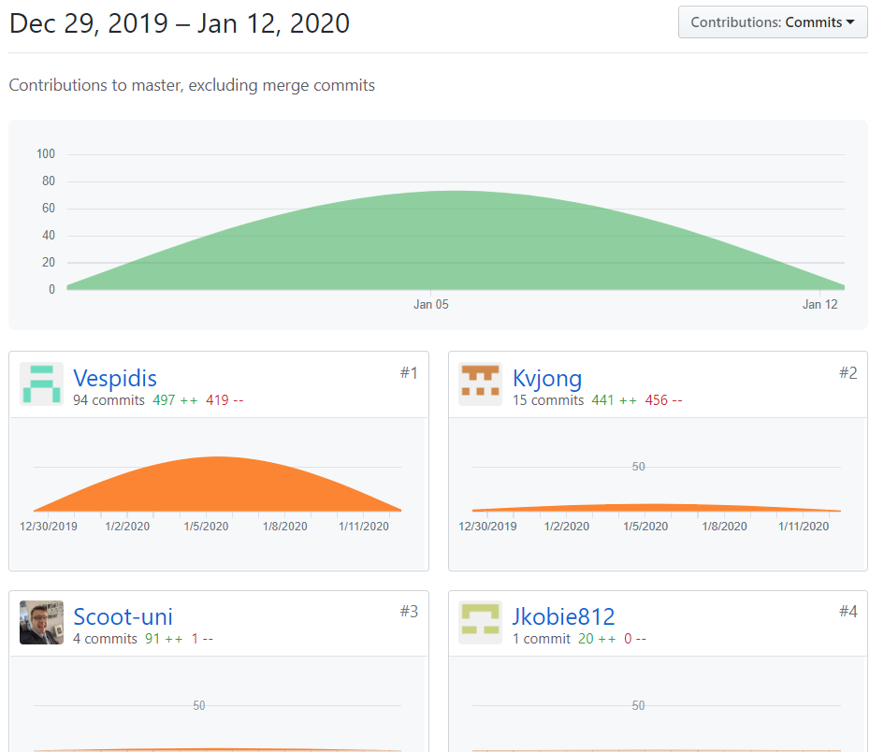

The breakdown of tasks as they were assigned:

Jacob - Crypto Report

Scott - Cloud Report, IT professional Interview

Kim - Burning Glass Data, creating & maintaining GIT repository, data compilation

Sam - Website, Cybersecurity Report, Job Comparison, Project Report, Observations on personality Tests, team leading and administration

David - Autonomous Vehicles Report, Compiling Data, Tools observation & Copy editing

Due to the nature of some of the work being done, the github audit isn’t 100% accurate, as some tasks only involve one file being uploaded that is a significant amount of work, such as the individual reports, compiling and copy editing, and the creation and maintenance of the repository itself. The audit is also biased in that it doesn't show any contribution from David at all as David joined the team late and has mostly focused on Compiling and editing.

That said one thing that is definitely clear and accurate is that the amount of work put in by Sam, who has by far put in the most work in organising, writing and analysis.

### Burning Glass

#### Individual Bio:

The ideal job and career for our group is varied, and the preferred / ideal career would be in areas such as from an IT analyst to software developer, IT Management and even a Policy Officer which has very little to do with IT. The following is a brief description of our group’s ideal role and field once we graduate from our current studies:

Samuel Jones – The preferred job is for a software developer / engineer with sufficient knowledge on coding languages such as: C#, Python and JavaScript. The required / desired database language is PHP, ASP.net, SQL coding, and the role requires a Bachelor of Science or similar. The required traits for the potential employment include: Excellent Communication skills, Presentation skills, problem solving and analytical skills and a team player. Samuel currently has experience and some exposure to Python and Javascript.

Jacob Smith – The preferred job is for a Business Information Systems Analyst and the preferred knowledge is on Microsoft Office, CRM, Microsoft Power platform like Dynamics 365, Lean Six Sigma, Virtualisation and database analyst including update. A minimum of Bachelor’s Degree is essential in the relevant areas and traits preferred for potential employment include: Problem Solving skills, analytical, ability to multitask, meeting deadlines and being able to prioritise. Jacob has an interest in IT and have always had great ideas on the application he wants to make. His skills include building a robust website and has some knowledge on information systems and coding.

Scott Smith – The ideal role for Scott is in the field of IT Management, Project leader and the preferred skills and knowledge include IT troubleshooting, ICT systems, Customer Excellence in maintaining systems, Windows SOE, Application Packaging in service and patching. The traits needed for the role include: Analytical skills, able to work under pressure, manage staff and organising skills. Scott’s past experience includes working for the Army before entering the IT sector. Scott has a wealth of knowledge and skills in the IT sector and currently employed in the IT field. Scott has undertaken further studies to broaden and deepen his IT Systems skills and eventually want to migrate to the field of Applications Packaging and testing stages of packages.

Kim Ve Jong – The ideal role for Kim is in the field of Policy for the Public sector. The skills needed for Policy is the understanding of Policy cycle, current legislation, departmental budget, Microsoft packages, understand the criteria and objective, prepare report for presentation and formulate advice. The traits needed for the policy role include analytical skills, problem solving, research, knowledge on current policy and legislation including law, being able to work under pressure and meeting scheduled deadlines. With Kim Ve’s current studies in the relevant field for Public Service, the degree has positioned Kim to pursue the role of Policy worker.

David Mulgrue – The ideal role for David is in the field of a Software Engineer specialising in iOS systems. It is a developer role for mobile devices by building reusable code and library for later use. The role also required collaborating with the backend team to integrate apps and API’s. The knowledge includes C, Apple tools, Android and Windows coding. The trait the for the suitable candidate includes presentation, analytical skills and problem solving skills.

#### Ideal Jobs – Group’s Core Skill Requirements

Based on our group’s desired career choice and our ideal paths that we all want to forge, we have identified our group’s core requirement:

* Communication
* Problem solving
* Analytical skills
* Time management

We all need to possess these core skills and do really well to succeed in our chosen career path, as these skills will be assessed, analysed, being judged upon, and form the basis of an impression. These four skills when forming a team for collaboration is a definite must, as failing to do so will ultimately break down, nothing gets done and over budget to cover these shortfalls. The team will also get disgruntled, for example, the group or a member of the group has poor time management skills and ultimately the project has not been completed by the scheduled time, and well, leave it to the (ether, it will sort itself out (the marker will sort it out!!)). Contrary to this notion, if the group embraces these four core skills, it is a recipe for success.

However, each of our group members also has a unique subset skill that is suitable and curated for their role more specifically. They are:

Presentation Skills – Samuel Jones – A unique set of subset skills required for the ideal job. This is very important because presentation in terms of powerpoint slides, dress code and grooming will set an impression, including an impression of the work. Even the way Samuel codes will need to have a proper structured coding that makes much more readable and not look like spaghetti style coding. So presentation skills for Samuel is a must.

Multi-tasking – Jacob Smith – The role of Information systems analyst may need to wear a different hat here and there, by the project being analysed. There may be multiple projects happening at the same time and applying efficiency by using a suite of applications for tracking, analysing, estimate, costing, resources and much more indeed does require multitasking and delegation. An example of requiring the knowledge of lean six sigma is a testament to the importance of multitasking.

Leadership – Scott Smith – The ideal role of IT Management / Leadership is leadership skills to guide and mentor staff to meet the objective requirements set by the organisation. Scott may need to wear different hats everyday, such as mentoring staff, sensitive conversation, meeting with upper management or a meeting with the group. As management, Scott also needs to possess customer excellence to retain external stakeholders, customers and clients to ensure the well being of the organisation.

Research – Kim Ve Jong – As an ideal work in the policy in the public sector, research is paramount to understand and articulate the formulation of policy or an update to policy change. There are so many components that make up policy, such as legislation, law from each states, political climate, data, and knowledge is an essential component. However, research skills play a crucial role in policy because it ensures that policy drafted is well refined and has been researched thoroughly covering aspects that is meant to be covered.

Below are the core skills requirement from Burning Glass data encapsulating our group’s core skills and our unique subset skill in demand of the industries.

When delving further to analyse the composition of the labour market in terms of industry types, IT is well suited in many sectors of the Australian industry, as each sector will depend on their IT systems to run their core business. With Kim Ve’s policy style of work however, it may well be suited for most industries, as policy ACT govern and regulate industries by setting the parameters on how they should operate. Below is a graph that shows the major industries in Australia by the Department of Jobs and Small Business:

[Australian Jobs PDF](https://docs.employment.gov.au/system/files/doc/other/australianjobs2019.pdf) on page 13.

Furthermore, the top job types in Australia data collected from the Department of Jobs and Small Business reveal the core role and positions filled in the Industry. For example the position of software and applications developer has around 123 thousand employed in that field and the ANZSCO code is 2613. Below are the graph for the team’s desired role encapsulated in the occupation matrix from the Department of Jobs and Small Business:

[Australian Jobs Occupational Matrix](https://docs.employment.gov.au/system/files/doc/other/australianjobs2019occmatrix.pdf)

Three Highest ranked skills not listed in our group:

Based on the data provided on Burning glass data, the three highest skills not listed in our group is organisational skills, writing and planning. However, the core skill requirements that our group has identified would be able to cover these areas adequately and with an additional member being David joining our team recently, we have expanded our capabilities and resource sharing.

From the list of IT skills in highest demand and not in our groups list are Graphic Design, SAP and Javascript. Although Kim Ve’s preferred policy role has very little to with specific IT software and hardware platform, it means these skills will be covered by the other team members and minimising this capability gap.

Opinion on Burning Glass Data

Our group opinion has not changed with the Burning Glass data as we are entrenched in our chosen field and will pursue that path. The length to assess has been too short, only two weeks to form an opinion, so there will be no changes. However, if the same question was asked a year or more later, then there is a chance that opinion will change, and with new Burning glass data to support that change in opinion if needed.

### IT Professional Interview

#### Shane Todd, Whizdom Recruitment

**What kind of work is done by the IT professional?**

Desktop Support Engineer. Contractor to the Department of Defence Since 2010.

As part of the Endpoint Services team, I am responsible for level 2 and level 3 support. That can involve the following:

* Replacing faulty devices; Mice, keyboards, monitors, KVM (Keyboard Video Mouse) switch boxes
* Relocating machines and equipment due to staff movements
* Running of Fibre Optic cable (fly leads)
* Patching of endpoints into the access layer switch
* Configuration of switch ports
* Troubleshooting of 802.1x Security protocol issues (which are quite common due to failing/expiring security certificates)
* Troubleshooting of Active Directory issues (expired computer accounts)
* Configuration of System Centre Configuration Manager (pre-stage machines prior to the build/image process)
* Liaising with other teams in order to resolve submitted tickets.

**What kinds of people does the IT professional interact with? Are they other IT**

**professionals? Clients? Investors? The general public?**

My clients/customers are Department of Defence Public servants and contractors. The organisation is spread across the world and my work can vary from simply replacing a keyboard on a desk located just down the hallway. Or it can involve sending a new machine to the other side of the world and guiding a person through the process of how to connect the cables and how to put the machine on the network.

Other people I deal with on a daily basis are other IT professionals. In my current organisation, the IT teams are setup in a very siloed arrangement. That means that my team is responsible for only a certain part of the IT environment. If troubleshooting an issue with machine, my team can check the physical parts that may be faulty. For example, we can check for broken fibre, faulty media converters, basic switch configuration. If the problem persists, we may need to liaise with the Network team to get a larger Subnet created.

**Where does the IT professional spend most of their time?**

Due to my role, I am very lucky that I am not stuck at my desk all day. Once I have received a job ticket in my queue, I may have to go to the workshop in order to get a replacement part. Then I would go to the client and resolve the issue. Another example is, if there was a requirement for a machine refresh, a fair amount of time would be spent by the team in the workshop on a "build bench" imaging/building machine after machine.

There are also times, when a member of my team is required to travel interstate or internationally in order to do a complete site refresh.

This can be a nice change of environment, however the tempo of the work can be quite high, as only a certain amount of time is allocated to

completing the work due to travel constraints.

**What aspect of their position is most challenging?**

Managing customer expectations. One of the things I have learnt from my time in IT, there are a certain amount of people that think they are the most important person in the world. This particular attitude comes from Senior Executive Service Band 3's down to an apprentice that has worked in the organisation for a week. Whilst I do acknowledge that people do have important work to do, it also comes down to priorities. I am unable to drop what I am doing, just because another person failed to plan. A good example is, I have a new starter coming into work tomorrow and their machine isn’t working. I can guarantee that person failed to plan ahead and ensure there was a working terminal with less than a days’ notice.

Shiny things. Recently our department received a shipment of new monitors. These new monitors were 27 inch and the existing fleet was 24 inch. We received a job to replace a faulty monitor and that was being replaced due to a power issue. Then all of a sudden, we received more tickets/jobs/requests from people located near that first faulty monitor. Turns out there was nothing wrong with their monitors, they simply wanted the new monitors. They saw something shiny and they wanted it to. It happens a lot. However, due to budget constraints, we are unable to replace monitors if there is nothing wrong with them.

### IT Technology reports

#### Clouds Services and Servers

Cloud computing is the delivery (or offering) of various computing services i.e. Databases, servers, storage, networking, and software over the internet.

Cloud computing has been a buzz word for a few years now, many organizations and individuals have transitioned their traditional services into the “cloud”. The first advantage of using cloud services that comes to mind is the flexibility and scalability of resources. Secondly, with cloud services, you only pay for what you use, so immediate savings can bee seen. You don’t have to build your own data centre and fill it with your own infrastructure.

Most companies are simply not in a position to go out and purchase land, build a data centre, purchase infrastructure, hire people to configure and install the aforementioned equipment. Then, after everything is up and running, they will need to man the data centre and sustain the infrastructure. By utilizing cloud services, they simply rent to access anything from a few applications terabytes of storage from a cloud service provider.

Apart from large companies, individual users are also able to rent cloud services. People and companies can rent simple storage solutions, networking and virtual computers through to high end processing power and massive storage that will run artificial intelligence platforms. Another advantage of cloud services are you are able to run any application or service that you don’t need to be physically co-located with. Your cloud services may be physically located in Belgium, and you may be located in Dubbo NSW.

As technology advances, network transmission speeds increase and that is being passed on by network service providers. Unless you’re in Australia where the National Broadband Network (NBN) has not kept up standard or speed with the rest of the world. Large businesses that are transferring and processing large amounts of data cannot afford to be left behind and they need to adopt the evolving technologies to stay ahead of the competitors. Cisco are offering up 400gb speeds on their Nexus 9000 series switches. With that amount of bandwidth, massive amounts of data can be moved around in a quick fashion.

Microsoft Office 365 is very popular cloud-based service that is available individuals through to large companies. Microsoft offer a web-based portal providing access to applications like Excel, Word, PowerPoint, OneNote, OneDrive and many others. For very little cost, people are able to use these applications without having to download the application to their machine, all of the information is saved offsite (providing redundancy) and allows the user to access their data from anywhere in the world.

With the ever-increasing demand for cloud services, vendors had to come up with a solution to address emerging latency and bandwidth issues. One solution was to offload some processing tasks done by the CPU and pass that to the network infrastructure. An example is: In the Data centre environment the Network interface Card needs to a SmartNIC, passing some processing tasks that would usually be completed by the CPU. SmartNICs can perform network-intensive functions such as encryption/decryption, firewall, TCP/IP, and HTTP processing.

To increase the speed and efficiency of the data centers, more and more sharing of resources will need to occur. Utilising SmartNICs, servers running Graphics Processing Units (to provide resources to virtual machines). There will be further progression in the structured cabling space too. Having the fastest processor, with the fastest Network Interface Card is very useless if the data is only running over standard Cat5e copper cabling. Data centre structure cabling provides connections between devices utilising Optic Fibre. With advances in this infrastructure space, we will see faster transfer speeds resulting in higher bandwidth. NICs with a higher bandwidth capacity will be a flow on of higher transfer speeds.

With more and more people wanting to access and utilise cloud services, there will be a greater requirement for edge or access layer network architecture. These edge nodes or some people are calling them mini data centres will be required to assist in processes the additional data. They will need to synch up with their central data centre and more than likely need to be interconnected with one another. There will be increased employment opportunities for many industries:

* People that specialise in optic fibre installation.
* Builders required for building new data centres or refurbish existing building to be re-fit as data centres.
* Electricians, there will be a massive increase in power demands for a data centre. So not only data centre electricians, but substations will need to be taken into consideration.
* Air Conditioners installers. Data centres require a large amount of cooling in order to keep the infrastructure at the desired operating temperature.
* Network Engineers. The basis of any data centre is a good network. These engineers will be required for ongoing sustainment too.
* Virtual Machine/server engineers. Thick client desktops are slowly becoming a thing of the past.
* Project Managers. Depending on the size of the data centre, there will be a need for a project management team to facilitate the install and sustainment.

An increase in Data Centres across the world will have a large impact on the environment. Care must be taken to minimise any short or long term damage to the environment. Using recycled building materials, the installation of solar panels, planting of additional trees, and recycled filtered water for system cooling are all examples that will help to minimise the impact on the environment. With the installation of more cloud services, there will be an impact on other parts of the IT industry. There will be less demand for desktop engineers. Users will be utilising either Thin clients or something on a BYOD platform.

Up until about a year ago, I was a strong advocate for applications installed on my PC or Laptop. Not utilising cloud based much at all. I worked in an environment where security was paramount and traditional cloud services (Amazon, Office 365) were not an option. It wasn’t a foreign concept to me, it simply didn’t get exposed to the mainstream cloud services (like Office 365) in my personal life. Another consideration I had was security. I only had the one machine, I knew that machine was secure. If anyone had accessed my information, it was both my fault and my problem. So, I kept all of my data local, backed up with redundancy.

Within the last year, I changed employers, security was less of a focus and they utilised Office 365. Due to a change of personal circumstances, I found myself travelling most weekends to visit family. There were plenty of occasions where I wanted to access a document that I thought was residing my laptop, but in fact it was sitting on my PC located 2 hours away in the “My Documents” folder. I initially used to email various documents to myself, however I was having version control issues. I was losing track of when I updated the document and if it was the latest version. I also started at my new workplace, that would throw in another computer to “lose” files on. Where was the latest version of that file I was after? Work, home or laptop. Enter Microsoft’s “One Drive” cloud storage solution.

“Automatic backup for your Desktop, Documents, and Pictures folders

Saving files to the cloud is now effortless. Just set up PC folder backup for any of the three PC folders and OneDrive will do the rest by automatically syncing any changes made or new files added to your backed up folders.” - https://onedrive.live.com/about/pc-folder-backup/

The cloud service is free for users that only require less than 5GB of storage. Whilst it marketed as an automatic backup solution, I tend to not use OneDrive for that use. I simply use it as a Cloud Storage ‘my documents” folder. That solves my access issues as well as my version control problem.

Almost 2 years ago I separated from my wife and as a result my 3 children aged 15 13 and 9 relocated around 2 hours drive from me. Whilst I only see my children every second weekend, my 2 older children and myself use Snapchat to keep in touch. Snapchat is a multimedia mobile app that allows my children and I to send videos, pictures to one another. My eldest daughter is by far the biggest user of Snapchat, she has daily correspondence with hundreds of her friends. The advantage for my daughter using Snapchat Cloud service is, that the images are not stored locally. She sends hundreds of pictures a day on Snapchat, most are photos of nothing (please don’t ask, it’s a teenager Snapchat thing), if she was required to take a photo and then send it, she would have to go through her phone daily and purge the unwanted photos.

With Technology moving forward, bandwidth increasing and with more Data centres being built there will be an increased availability of types of services. As my children and I use mobile phones for the Snapchat application, I am hoping with advancing technologies there will be better coverage. With better coverage I believe there will be greater bandwidth to communicate easier and faster. Being able to communicate all the time, no matter where we are is very important to us, as we do not live together.

#### Cybersecurity

##### What does it do?

Cyber security is an all-encompassing topic that over the last 10 years has become more and more prevalent in the public eye, but still retains an aspect of mystery as we transition into the age of information and technology. To give a brief overview of topic that cyber security covers, one need only make a brief list to begin to see the scope of the topic; Network security, Application Security, Identity management, database security, mobile security to name a few. However, the nature of cybersecurity is simple. To protect the integrity of networks, programs and ultimately sensitive data from damage or illegal access.

One of the most prevalent and upcoming technology for cyber security revolves around deep learning. The concept of deep learning is broader than just in regards to Cybersecurity, but essentially it’s the combination of machine learning and artificial intelligence to identify patterns through a type of deductive reasoning that uses contextual clues to indicate what is happening, this is based off and similar to the way human brains work. A current and widely used application for deep learning is image detection where each of the layers detects a pattern in an image that it has learned from previous images.

Two significant areas of cybersecurity that are greatly improved by deep learning is malware detection, and network intrusion. This is because systems like malware detection are currently heavily based on rule-based detection methods to deal with known threats. This leaves easily exploited holes in security due to the ability for attackers to simply tweak the malware signature to evade any current detection system. A significant benefit of this type of malware detection is that it can be applied to all types of platform including computers, smart devices and mobile phones.

By utilizing deep learning, we are able to treat malware programs like images, and apply deep learning techniques on these images to classify them as either malware or safe, this allows us to draw from commonalities in malware and to detect threats that may not fulfill all the rules of a traditional detection method.

With this being said, whilst an important aspect of cyber security is software, a lot of personal security relies on user generated passwords and protection, and it is eminently evident through repeated security breaches of people’s personal data that these methods are not adequate, as users have a tendency to use weak, easily identifiable passwords that can be breached with little to no effort for professional hacking individuals or groups. This has sparked a resurgence in hardware and multifactor authentication to add a further and less user-reliant form of protection.

Hardware authentication is both traditional, and new in many ways. It has been used by banks for a long time in the form of ATM cards, and some banks have used security tokens also, but is now more than ever accessible with the use of personal mobile devices as a secondary point of security. Companies like Google and Apple are now relying on user generated passwords, and a secondary point of verification usually in the form the user’s personal mobile device.

The impact of both of these technologies is profound on both a professional and personal level. For business’ deep learning technology is becoming near essential as we move towards a total reliance on technologically integrating business practices into the IT space. However, this progression also means significant risks, potentially crippling business’ if there are breaches to systems, which means lost revenue, and lost revenue depending on the impact can break business’ who are on the precipice.

Though the positives of deep learning cannot be stated enough, it also carries the risk of reduced jobs. As current malware and detection requires manual engineering that is consistently tweaked by software engineers. Removing the manual element allows more sophisticated and faster paced adaption to threats, but also may remove jobs that are currently essential to business’.

With regards to business’ and two factor authentication, it is common practice for major organisations to utilise key generating software and apps like authy in addition to passwords to add a secondary layer of protection for their networks. However, we may see in the near future a more biometric focused type of two factor authentication for business’ and or a wider adoption of hardware authentication in the form of keys.

On a more personal level, we may begin to see companies utilise their enormous data troves to create extremely sophisticated deep learning networks and integrate them with all future personal devices. However, in the near future, and currently we will be more impacted by the use 2 factor, and hardware authentication on more and more platforms. Companies like Mozilla and Apple are beginning to require two factor authentication for all add-on developers, and more and more companies are making 2FA a requirement, in fact google has launched an advanced protection program which utilises hardware keys that requires you to use these keys every time you want to log in to your account.

### 

#### Autonomous Vehicles

The current state of Autonomous Vehicles as a whole is, frankly, an absolutely huge subject.

The simplest and most core of the idea is that a vehicle can, with the assistance of an onboard computer and sophisticated sensor technology, act in accordance with its surroundings to take action without the direct input of a human driver.

The general classification of autonomous vehicles comes under a five tier system, with each tier having specifics of what the vehicle can do, from simple driver assistance tools all the way up to fully automated trips between places without the need for human intervention.

In depth discussion of the technology is easiest with a knowledge of these tiers, which are laid out below.

##### Tier 1

Driver assistance technology is the most common and longest existing of autonomous vehicles, and some of these technologies have been around since as early as the 1950s.

These are relatively simple technologies such as cruise control, anti-lock brake systems (ABS) and stability control. These are all systems that will add convenience to a driver’s commute and safety while still requiring a human to stay in complete control of the vehicle.

##### Tier 2

The second tier of vehicle autonomy is the limited automation of one feature at a time in limited circumstances. Some variations of this technology have been around since around 2000 and the most well known of these technologies is automatic emergency braking, which will use sensors in the front of the car to automatically slow or stop the car when an obstacle is sensed in front of the car, such as a slower vehicle in the lane in front, a stationary obstacle sitting in the road, or in some cases an animal or person moving into the path of the vehicle.

##### Tier 3

Tier 3 is the highest version of autonomous vehicle technology that is available to the general public, with several large car manufacturers currently developing and improving their current offerings. Tier 3 allows for the onboard computer handling two or more simultaneous functions driving the vehicle, such as cruise control, automatic braking, and lane keeping.

Vehicles with this level of technology are able to maintain current actions, such as following a lane, sticking at a specific speed, and potentially avoid low speed collisions, but still require an active driver in control of the vehicle. Many of the vehicles of this level have driver monitoring implemented, so that if the driver is not paying appropriate attention to the operation of the vehicle, it will slow and move itself off the road to prevent potential accidents that the computer cannot handle by itself.

##### Tier 4

Tier 4 automation technology is still largely in development. It is able to largely take control of the vehicle, take full control of entire trips, and importantly does not require continual oversight from a human driver. A vehicle with Tier 4 automation is mostly able to handle emergencies and changes of circumstances, especially when in a controlled environment, but will notify the driver if and when anything occurs that it is not able to take care of by itself. With a vehicle of this type the driver would be free to undertake other tasks while being driven but should be awake and ready to take control if it is required.

##### Tier 5

Tier 5 automation, simply put, is complete and total automation of the vehicle. A tier 5 automated vehicle would be able to take any and all actions required to undertake travel completely alone without any input from a human whatsoever.

As stated above, tiers 3 and 4 are the most heavily under development at this time, with tier 3 being available to the public and being improved and refined while in use, and Tier 4 being actively under development but only available for use under strictly controlled circumstances.

Generally they use a combination of a number of different sensors including RADAR, LIDAR, and ultrasonic sensors to be able to tell what is going on around them, and utilise machine learning to improve and adapt based on what actions have been taken in similar circumstances previously.

A very large amount of the improvements in the quality of vehicle automation in the near future is going to come from machine learning, with Tesla making great strides in this department as they currently have the largest user base with all of their current model vehicles having their Autopilot installed as a standard. Machine learning takes cases where either an onboard computer tries something new, or records what the human driver’s intervention is, and records it for future use so that it can improve its reactions in future. It then will send the information back to the manufacturer where it is propagated across the entire range of vehicles, often on a per-manufacturer basis.

As an addition to this, there is a small number of firms working on a technology called “Vehicle to Everything communication” or V2X, which extends the idea of vehicles talking to each other, and adds traffic lights, weather services and other road services to the mix, allowing the vehicle to know more easily in real time what is happening around it, including traffic and road conditions, and with enough autonomous vehicles on the road, nearly eliminate the incidence of traffic accidents.

There are many potential impacts of wider improvement and implementation of autonomous vehicle technology, across several different industries.

To taxis in the short term it will make the driver’s job a lot easier, with the ability to simply input a destination and watch to make sure nothing happens. Unfortunately as the quality of the automation progresses, the drivers themselves will become less and less necessary, eventually reaching a point where an entire fleet will be controlled from the head office with no need for human oversight.

Similar could be said for the Trucking industry, with a huge pool of jobs that will be made simpler and less tiring on long drives in the short term, with there already being speculation that the local driver providing input in case of an emergency could be replaced by a remote driver overseeing large numbers of trucks and monitoring them for the need for human input.

Potentially the biggest industry these improvements will have an effect on will be the IT industry.

There is already a very large number of projects that are utilising machine learning and rudimentary AI in their technological research, and with the sheer size and scope of work being done on autonomous vehicles, the improvements in machine learning could be a driving force (pardon the pun) towards huge improvements across the board for software that will learn and adapt from previous experiences. Improvements in machine learning software for cars can potentially lead to improvements in a wide array of uses such as virtual personal assistants, email and spam filtering, and a whole variety of other applications.

On a more personal level, improvements in self-driving vehicles will have a huge impact to me on both a personal and a professional level.

A vehicle that is able to travel autonomously would mean being able to focus on other tasks while travelling, either locally or over long distances, which would alleviate boredom, fatigue and time that could be spent in other ways while travelling. It would open up the ability for me to more regularly visit friends and family in other cities and states across the country without losing valuable study and work time to travel.

To some of my family members the biggest benefit would be similar; the ability to conduct business, communicate with clients and continue working while travelling to collect mail or visit clients would be invaluable.

#### Cryptocurrencies

Blockchain and Cryptocurrencies are a fascinating development that is currently ongoing in the IT world. It changes the way products and services can be paid for online, and with new upcoming developments, in person as well. Historic examples of this magnitude include the internet, smartphones, cloud computing, and public-key cryptography.

Blockchains are an internet based record keeping technology most well known as the technology behind bitcoin. Blockchain i sa distributed, decentralised public ledger, that could be described as a chain of blocks holding digital information. These blocks are able to store all sorts of information, such as the date, time and value of a purchase, who is participating in a transaction using a digital signature, and unique identifiers for the blocks themselves, called a Hash.

Every single block’s hash is unique. Even if you make two separate transactions at the exact same time, of the same product from the same source for the same amount, the block’s hashes will be unique and different so they can be told apart.

Public-key cryptocurrency is based on the internet is used to make trades anonymously. The most important feature of these cryptocurrencies is that they are not controlled by any central authority; the decentralised nature of the blockchain makes cryptocurrencies immune to government control and interference. Cryptocurrencies can also be sent between two people using public and private keys to avoid the cost of major bank fees.

Bitcoin is “Mined” by computers around the world by processing transactions on the blockchain with distributed computing.

As of the time of writing, the current price of bitcoin is $11,756.65 in australian dollars, and increasing global uncertainties will likely push more investors into bitcoin as it becomes recognised as a store of value.

While Bitcoin mining can be mined on a smartphone, it’s not a worthwhile solution as it will use a lot of energy for a relatively low power device; most bitcoin mining is undertaken on desktop PCs and in a larger amount by specialised large servers.

The better use of a smartphone when it comes to cryptocurrencies is as storage for your Digital Wallet. These digital wallets are used with most cryptocurrencies as a way to store your money; these style wallets are used, among others, by Bitcoin, Ethereum, Ripple, Litecoin, and Bitcoin Cash.

The wallet stores the public and private “Keys” or addresses which can be used to send or receive the currency. With the private key it is possible to write in the public ledger, effectively spending the associated currency by assigning it to another person’s key. The public key is used as a receiving address, which people can use to sign their currency over into your wallet.

Cryptocurrency is currently illegal in a number of countries, including Algeria, Egypt, Morocco, Nepal and Pakistan, and the countries that have a Banking Ban are Saudi Arabia, Jordan, Iran, Bangladesh, India, China, and Cambodia. These banking bans are essentially the local reserve bank disallowing any banking organisations from accepting or trading in cryptocurrencies.

However as the development of bitcoin is decentralised it is a promising development for a more financially inclusive world.

The rise of cryptocurrency can potentially have a huge impact on the real estate industry as it currently relies on an inefficient loop between Attorneys, financial institutions, and real estate agents, which has the effect of making transactions slow and cumbersome. This ineffective loop stems from a lack of guarantees of trust between parties, which can escalate costs by as much as 10%.

Blockchain technology and the use of smart contracts can revolutionise this process while complying with legal requirements. The smart contract code will facilitate, verify and enforce the negotiation or performance of any agreement or transaction.

Of course these advancements, while they are able to massively expand access, still require massive changes to financial law; they need a legal framework that is responsive and will enable them to work, and there are a lot of regulators and innovators in the tech space that are working hard to address this needed change. A leader of this is the Financial Services Commission in Barbados, who have created a working group to consult on the creation of new financial regulations that can be applied to digital assets, and propose new regulatory sandboxes for individual products. This approach to regulation focuses on having no more or less regulation than is required to eliminate systemic risks and minimise consumer vulnerability, while still leaving breathing room for innovation. Some particularly necessary changes include modification of the legal requirements for stock exchange so that they cover digital assets, while maintaining compliance with anti money laundering and know-your-client requirements.

These legal modifications will bring financial law into the new era, and the regulators in Barbados are well underway to making these changes.

There are unfortunately a substantial number of drawbacks with cryptocurrency as well; As a person’s wallet is secured with a private key, there is a not insignificant number of hackers that will attempt to steal the key to make off with the data; as the keys are anonymous and not regulated by any governing body, they are also susceptible to theft with little recourse.

The anonymity also lends itself to shadier uses, with the well known and very large Silk Road website being an example of people being able to buy drugs, weapons, and other illicit substances and services with no legal oversight.

Another massive issue is one of energy use; as it currently stands the popularity of bitcoin has led to huge racks and data centres full of servers mining bitcoin, which uses huge amounts of energy. This has gotten to a point that not only is there little profit to the venture with the amount of money required to buy hardware and keep up with energy requirements, but it also has a very large carbon footprint.

### Group A2Group8 Project Report: Touchglobe

Together as a group we decided to settle on utilising the project idea of TouchGlobe, originally envisioned by Sam Jones, due to the fact it was a straightforward concept with real-world applications that are desirable and practical for businesses to implement without significant cost.

TouchGlobe is essentially an online booking UI for the cruise industry, that is designed to fill what appears to be a glaring hole in the design of current online booking Systems for cruise lines. As we can see from the following basic searches on three major cruise line websites ([Norwegian Cruise Line](https://www.ncl.com/au/en/vacations?ships=Norwegian_Jewel), [G Adventures](https://www.gadventures.com/destinations/asia/indonesia/)) each of these business’ utilise a simple search list feature for planning holidays with them, which may be suitable for some guests, does not provide a kinaesthetic or audio interaction in any way, in addition to this, it provides low user interactivity, which has been linked to higher engagement.

TouchGlobe offers to solve that problem, by utilising an interactive booking experience for the user. This will hopefully mean better user engagement and a higher amount of bookings for the target company, because at the end of the day, the goal is profitability.

TouchGlobe is an interactive world globe which walks the user through the booking process whilst keeping them engaged and interactive all throughout the experience. The process begins when the user selects to “Plan a holiday” on the companies website, it will then prompt the user with qualifying questions, including “where would you like to travel” and “when would you like to travel”, this will cause the TouchGlobe to rotate and highlight the area of travel they have selected. (IE they have selected Spain, or the Baltic, etc) and it will utilise a library for nearest available cruising destinations if the user inputs an invalid option, for example, you cannot cruise to Berlin in Germany, but there is a port available approximately 3 hours away called Warnemunde. Adding qualifiers in at this point of the process means a much cleaner visual experience for the user, as most cruises will have hundreds if not thousands of cruises available over the course of a year. Once the Globe is initialised and rotated to the destination and timeframe the user has selected it will highlight in green the ports of embarkation for cruise holidays, and in yellow all the ports that they can visit in that area.

From here, the guest can look at the following information for each type of pin.

* Available cruises to that destination
* Port overview including basic information such as; weather during the time they have selected, port access information (transfers etc), simple description of the port. (These descriptions should all be available as audio descriptions also)
* Sight-Seeing/Shore excursions, which provides information on nearby points of interest, or bookable shore excursions available from that port. (Descriptions of shore excursions are all available as audio descriptions also)

Once the guest selects a cruise, globeTouch will highlight their cruise of choice and map it, so the guest can see all ports of access, alongside the direction of travel so they can make informed decisions for their cabin selection. From there the standard booking process is followed through the booking engine of the company utilising globeTouch.

Regarding development of the project, the requirements are straightforward – Javascript for the interactive globe, HTML and CSS for the website design and integration and a UI designer to make sure that the systems match the visual experience and lastly some sort of back end integration to the parent companies booking engine (the language these are written in tends to vary, so I have not specified the requirements).

Ultimately, as we discussed earlier, the end goal is providing a better user experience which also results in a higher conversion rate for the cruise company, and because of the low upfront investment in this system this seems quite likely.

### Group Reflections

#### Kim Ve Jong:

Since forming our team over a month ago in early December, we have had collaboration ever since using the Discord software. The group has been really supportive and we have delegated our work appropriately with each member contributing each section of work. My responsibilities include creating the Github repository and regulate the repository, and the report on Industry Data with Burning Glass. I have worked with everybody’s bio from assignment 1 and incorporated into our assignment 2’s bio. Now, some of the members in our group work full time and in my case, I work in the afternoon shift and sometimes cannot chat in the evening session. However, when I got home around 2am, I quickly attend the task the group has set out earlier and they usually respond in the morning. The team also adjusted and included collaborating during the morning as well. So, by around Christmas we had an active channel and typed regularly throughout the day to get the latest update including the update on Github. With an additional member being David that recently joined our group, he has quickly settled in our group and took responsibility for his share of the work. Samuel Jones has played a crucial role in our group and has shown leadership amongst the group and have been quite active in updating the Github repository. Below is a snapshot in our updates on Github files and documents.

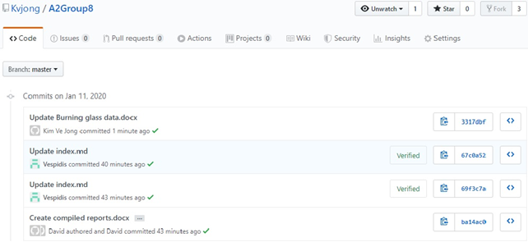

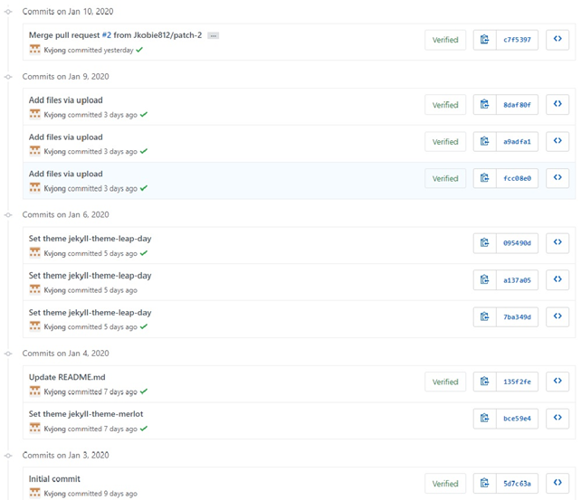

#### David Mulgrue:

This group assessment has been fraught with difficulties which thankfully have all ended up being resolved at the last moment.

My first group seemed to be working well, but due to some miscommunication over the holiday period I ended up being removed from the group and placed in an auto assigned one.

I made multiple attempts to make contact with the members of this group but was unsuccessful, in the end I managed to make contact with a group who had open space and could use an extra person to help with some reports and polish some of the documentation, which I was more than happy to do.

I’ve found that while this group has had some relatively small communication problems, the quality of the work has been excellent and I have had no issues with slotting myself in and compiling the work and adding my own to make a complete and comprehensive set of reports.

#### Scott Smith:

I have worked in many teams in my career, made up of people from various backgrounds and cultures. This is the first time that I have worked in a team of people that I haven’t met. As we are only a couple of days out from submission date, overall, I feel that our team has worked quite well together. We were off to a “shaky” start due to the Christmas period and most of us working different jobs, particularly those that work in a shift work environment.

We initially tried to do voice discord chats, that didn’t work out well due to the aforementioned reasons. So, we ended up using Discord text chat which was a far better solution, people could reply when they had a chance. Once we had our communication sorted, tasks were assigned, and we were able to work within our own time for overall compilation later. We could have improved by communicating earlier.

Once thing that was surprising (but not bad) we had a new member join our team only 6 days out from submission. The member was having problems communicating with his own team, so we felt we were in a position to help him.

One thing about groups, every person has their own ‘pros and cons’ communication is key. You can’t rush things, everyone has their own busy schedule.

#### Samuel Jones:

Everyone contributed fairly to the assignment, and it was smooth regarding that. Nobody avoided doing any work that they were asked to. However, we definitely should have been more organised leading into the New Year, despite the fact that it was a holiday period, leaving everything till the last minute put a lot of pressure when we were all returning back to work and had other subjects to work on as well. One of the more surprising aspects for me was looking at the groups varying jobs and realising just how diverse the industry was. For me the biggest thing about group work is structure, everyone understanding their responsibility and having work be divided in a fair way, that also appeals to the strengths of each individual rather than lumping them with work they can’t do is vitally important.

Below is a snapshot of our group’s activity in Github:

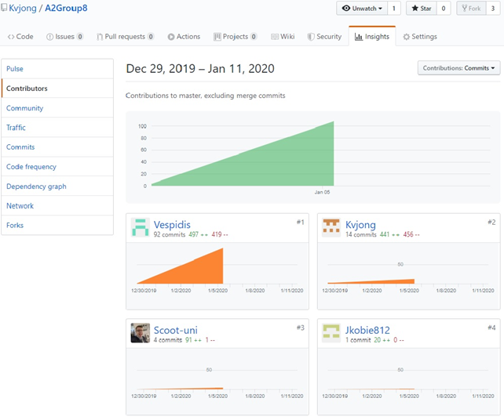

Below is a snapshot of our group chat in Discord. We have two channels and have been communicating on a daily basis since before Christmas.